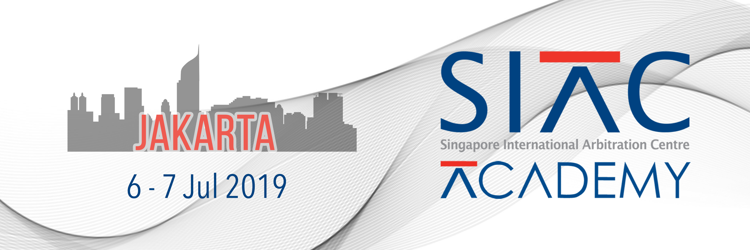
SIAC Academy Jakarta 2019
6-7 July 2019
Application Form 2019
Please complete this form and submit the completed form with your CV. The form must be typewritten.
Only complete applications will be considered. Please complete one form per applicant.
SALUTATION | ( DR / PROF / MR / MRS / MISS / MDM )* Delete accordingly
FIRST NAME
LAST NAME
GENDER
DATE OF BIRTH (DD/MM/YYYY)
NATIONALITY
COUNTRY OF RESIDENCE
ADDRESS
CITY
STATE
COUNTRY
POSTAL CODE
EMAIL
MOBILE NUMBER

ORGANISATION
DESIGNATION/
JOB TITLE
CATEGORY | ( STUDENT / IN HOUSE / PRACTITIONER / OTHER ) * Delete accordingly  IF OTHER, PLEASE SPECIFY  __________________________________________________
ARBITRATION EXPERIENCE
HOW DID YOU LEARN ABOUT THIS ACADEMY?  (PLEASE TICK BOX) | ❒ SIAC WEBSITE ❒ EMAIL INVITATION  ❒ SIAC EMAIL INVITATION ❒ SOCIAL MEDIA  ❒ SIAC SOCIAL MEDIA ❒ FRIEND / COLLEAGUE  ❒ WEBSITE ❒ INTERNET SEARCH  ❒ OTHER IF OTHER, PLEASE SPECIFY WHICH ORGANISATION (IF APPLICABLE)  _________________________________________________
WOULD YOU LIKE TO BE ON OUR MAILING LIST  (PLEASE TICK BOX) | ❒ YES ❒ NO
WOULD YOU LIKE TO JOIN YSIAC AS A MEMBER?  (PLEASE TICK BOX) | ❒ YES ❒ NO  NOTE: I CONFIRM THAT I AM UNDER 40 YEARS OF AGE. I WOULD LIKE TO JOIN THE YSIAC AND SIGN UP FOR THE YSIAC MAILING LIST TO RECEIVE UPDATES ON YSIAC NEWS AND EVENTS.

Application instructions

To apply, please submit the completed Application Form 2019 (Pages 1 & 2).
These documents must be submitted to: events@siac.org.sg stating “Application to SIAC Academy Jakarta 2019’’ in the email subject line.
The Committee will base its decision on the fulfilment of the admission criteria.
Applicants will be notified via email of the Committee’s decision regarding their application.
Upon receipt of the notification of acceptance, applicants are encouraged to immediately begin their hotel and travel arrangements as well as any necessary visa applications.

Registration Fee (All payment must be made in USD / SGD)
In-house counsel / Students – Complimentary
YSIAC Members* – IDR 2.900.000,-
* YSIAC membership is free (http://www.siac.org.sg/ysiac/about-us/how-to-join-ysiac)
Early Bird Rate** – IDR 4.300.000,- until 21 June 2019
** To qualify for the Early Bird Rate, the deadline for submitting your application is Friday, 21 June 2019. Should we receive your application after the deadline, the Standard Rate of IDR 5.700.000,- will apply.
Standard Rate – IDR 5.700.000,-
(Participants who attend both days will be issued a Certificate of Attendance)
Fees include:
- Academy programme, which will be provided in advance of the Academy to all admitted participants
- Course material, which will be made available on the first day of the Academy
- Lunch on 6 & 7 July 2019
- Coffee/Tea during coffee breaks
- Networking drinks on 6 July 2019

Mode of payment upon acceptance
YSIAC Members:
- Telegraphic Transfer (USD 240.45 / SGD 343.50)
- Credit Card (USD 213.86 / SGD 305.52)
Early Bird Rate:
- Telegraphic Transfer (USD 338.45 / SGD 483.50)
- Credit Card (USD 317.10 / SGD 453.01)
Standard Rate:
- Telegraphic Transfer (USD 436.45 / SGD 623.50)
- Credit Card (USD 420.35 / SGD 600.50)

Method of Payment
SIAC accepts payment by any of the following methods:
- credit card; and
- bank transfer

Payment of registration fee must be made in USD / SGD and should only be made upon notification of acceptance by the SIAC Academy 2019 Secretariat. Full payment must be received before the event date. Further payment details will be provided in the notification of acceptance.
Cancellation & Refund
Cancellations after acceptance are non-refundable.

Attendance
Participants admitted to attend the SIAC Academy Jakarta 2019 will be expected to attend all sessions over the 2 days. Course assignments will be emailed to participants who have made full payment.

PDPA
By participating in this event, you hereby agree that the personal data that you have provided to SIAC:

- shall be collected and stored in SIAC's database of contacts;

- may be processed and stored by a data intermediary appointed by SIAC whether in Singapore or elsewhere;

- shall, in the case of your name, job title, organisation and country (and no other information in the nature of personal data as defined by the Personal Data Protection Act 2012 (No. 26 of 2012)), be made available to any sponsor(s), co-organiser or co-host of the event, speaker(s) at the event and other delegates attending the event;

- shall, in the course of SIAC's course of business, be used and collected for data analytics, review, the marketing and organisation of conferences, courses, seminars, lectures and events in the future.

Useful Information
- Venue
Assegaf Hamzah & Partners
Level 36 & 37, Capital Place
Jalan Jenderal Gatot Subroto Kav. 18
Jakarta 12710, Indonesia

- Travel & Accommodation
Travel and hotel expenses are not included in the registration fees.
Participants are responsible for making their own travel and accommodation arrangements, as well as any necessary visa applications.

- Dress Code
Business Attire

- Language
All sessions will be conducted in English.

- Contact
For further information, please contact events@siac.org.sg

